**Represent some Diagram on Power BI :-**

**Histogram :**

a graphical representation of data distribution, where data is divided into intervals called bins, and the height of each bar represents the frequency or count of data points within that bin.

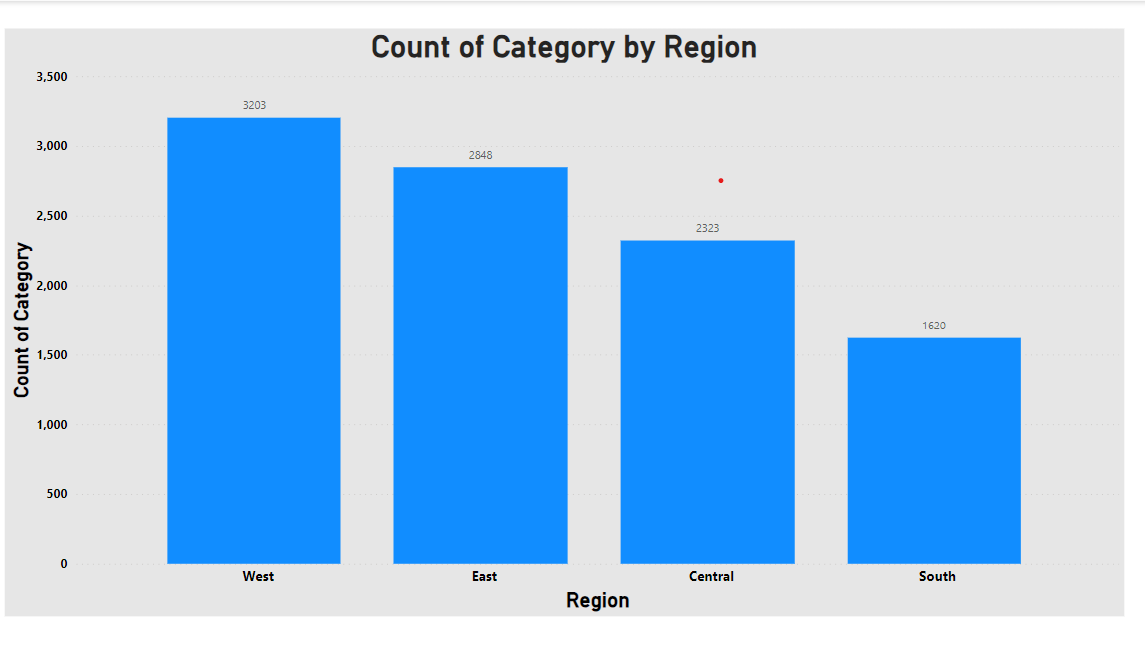

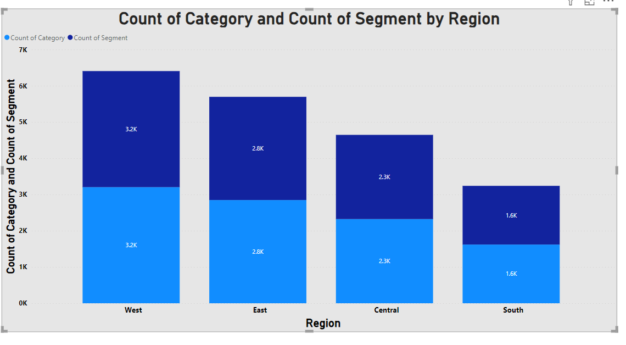

**Pie Chart:**

A circularchart divided into sectors, where each sector represents a proportion of the whole data set. It is used to show the composition of a whole, with each sector representing a percentage or proportion of the total.

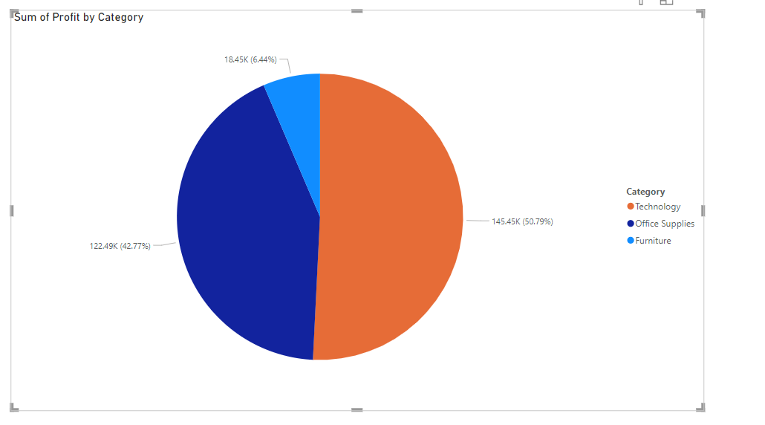

**Line Chart:**

Line Chart: A graph that displays data points connected by straight line segments. It is commonly used to track changes over time or to show trends in data**.**

